The Camunda WildFly MySQL configuration

Sumit Vadaviya

Camunda BPM Expert, Corporate Trainer

Email : sumit.vadaviya@trainosoft.com

I

n this session we will install camunda WildFly Camunda and configure MySQL database.

# **1. Software required**

* Download Community version of Camunda camunda-bpm-tomcat-7.13.0.zip

<https://downloads.camunda.cloud/release/camunda-bpm/wildfly/7.15/camunda-bpm-wildfly-7.15.0.zip>

* Download JDK 8.

[JDK 8](http://www.oracle.com/technetwork/java/javase/downloads/jdk8-downloads-2133151.html)

* Download MySql Database

<https://dev.mysql.com/downloads/installer/>

* MySql Workbench

<https://dev.mysql.com/downloads/workbench/>

# **2. MySql JDBC Driver**

**2.1 Download MySql Driver(mysql-connector-java-8.0.12.jar)**

[MySql JDBC driver](https://repo1.maven.org/maven2/mysql/mysql-connector-java/8.0.12/mysql-connector-java-8.0.12.jar)

* mysql-connector-java-8.0.12.jar is required to setup database connection from camunda to

Set JAVA_HOME and PATH environment variables.

Set JBOSS_HOME and PATH environment variables.

# **3. Start default camunda WildFly server**

Download camunda WildFly [camunda-bpm-wildfly-7.15.0.zip](https://downloads.camunda.cloud/release/camunda-bpm/wildfly/7.15/camunda-bpm-wildfly-7.15.0.zip) and extract it

**Navigate to camunda-bpm-wildfly-7.15.0 and execute start-camunda.sh/start-camunda.bat**

sumit@sumits-mbp camunda-bpm-wildfly-7.15.0 % ./start-camunda.sh

It will start camunda WildFly server with H2 as in-memory database.

# **4. Accessing Camunda**

Camunda application can be accessed from [http://localhost:8080/camunda/](http://localhost:8090/camunda/)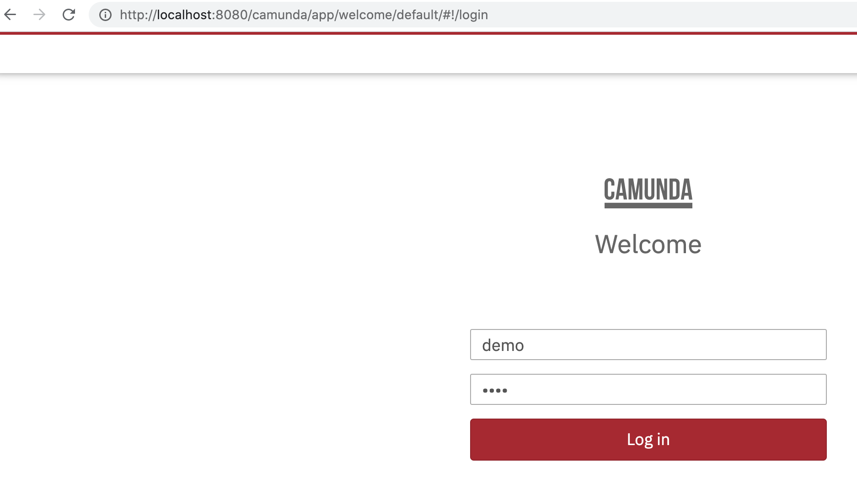

Enter the default credentials as given below.

**Username:** demo

**Password:** demo

demo user has admin role by default.

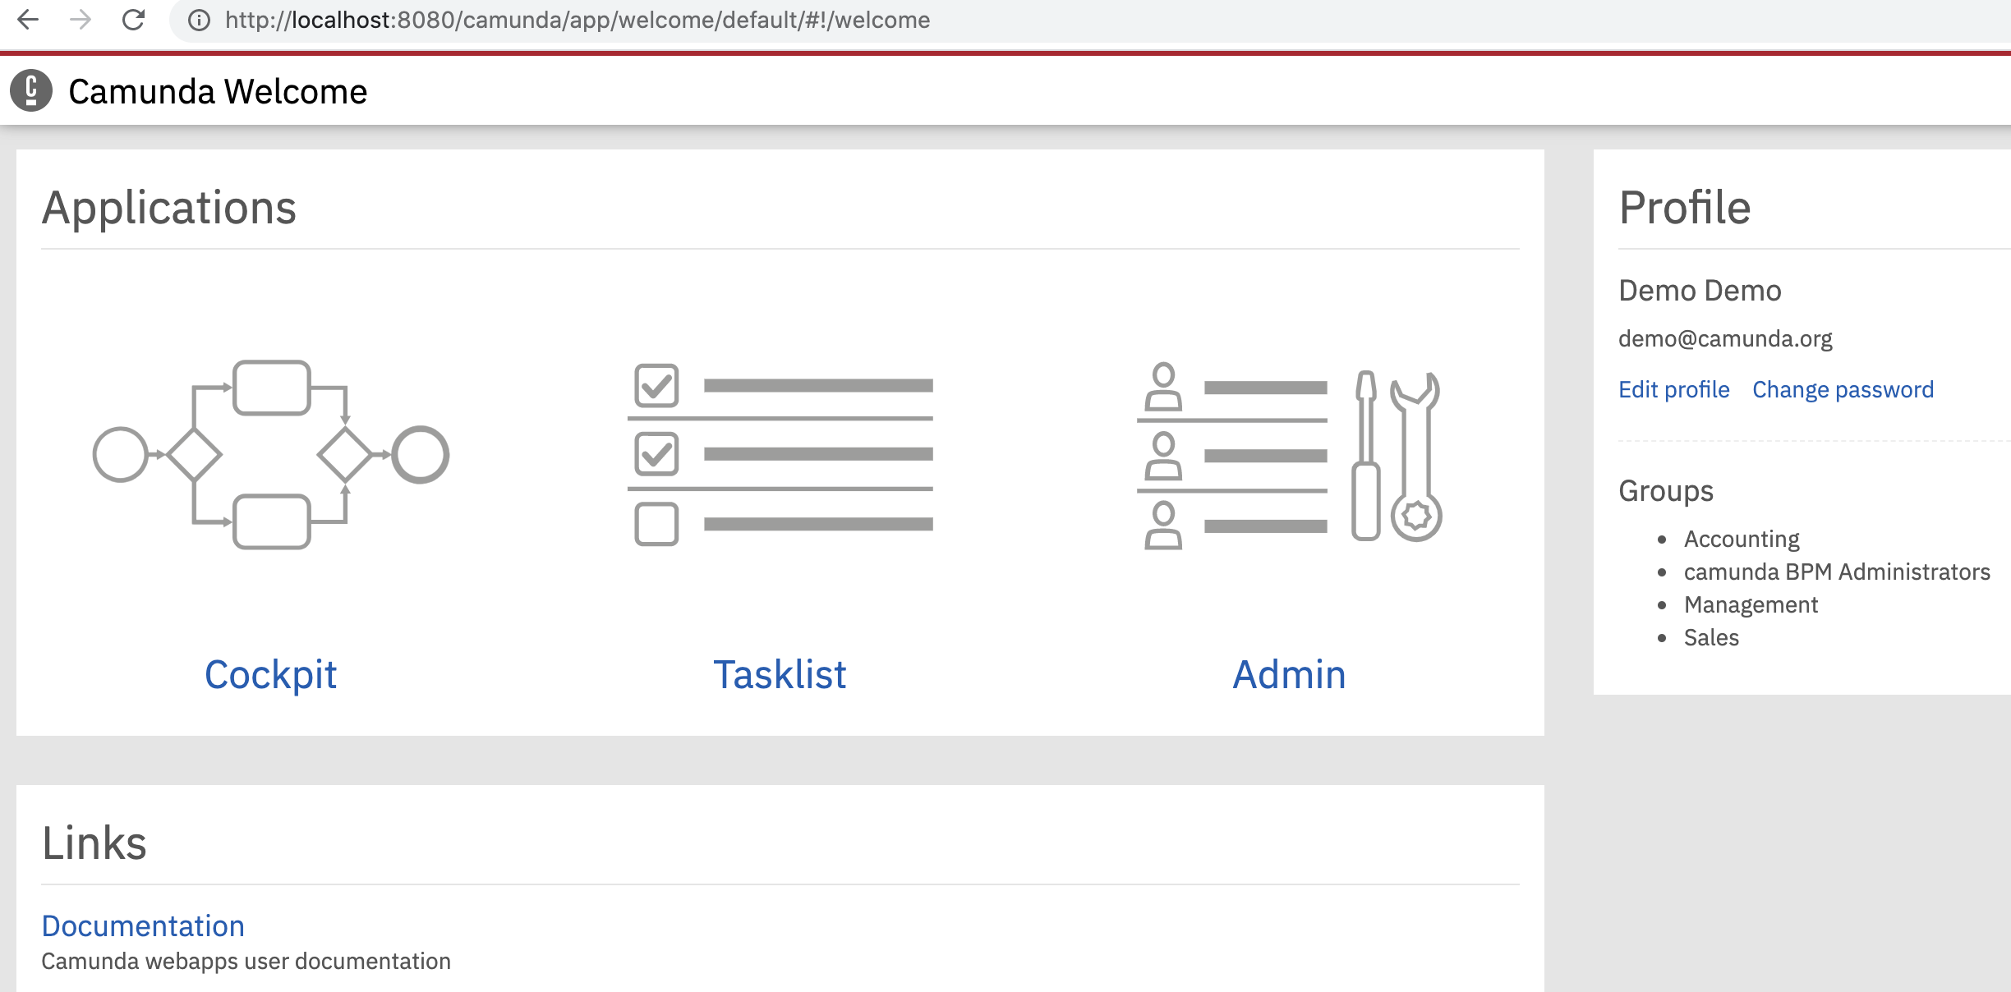Once you sign in to the app, you will see different tabs for performing various tasks to start with the business processes.

* Hit the below url in the browser

http://localhost:8080/camunda/app/welcome/default/#/welcome

# **5. Accessing server log**

# camunda-bpm-wildfly-7.15.0/server/wildfly-22.0.1.Final/standalone/log/server.log

# **6. Replace H2 database with MySQL database.**

# Open/Volumes/Trainings/Camunda/Softwares/camunda-bpm-wildfly-7.15.0/server/wildfly-22.0.1.Final/standalone/configuration/standalone.xml

# Replace comment out H2 DB configuration

<!--

<datasource jndi-name="java:jboss/datasources/ExampleDS" pool-name="ExampleDS" enabled="true" use-java-context="true" statistics-enabled="${wildfly.datasources.statistics-enabled:${wildfly.statistics-enabled:false}}">

<connection-url>jdbc:h2:mem:test;DB_CLOSE_DELAY=-1;DB_CLOSE_ON_EXIT=FALSE</connection-url>

<driver>h2</driver>

<security>

<user-name>sa</user-name>

<password>sa</password>

</security>

</datasource>

<datasource jndi-name="java:jboss/datasources/ProcessEngine" pool-name="ProcessEngine" enabled="true" use-java-context="true" jta="true" use-ccm="true">

<connection-url>jdbc:h2:./camunda-h2-dbs/process-engine;DB_CLOSE_DELAY=-1;MVCC=TRUE;DB_CLOSE_ON_EXIT=FALSE</connection-url>

<driver>h2</driver>

<transaction-isolation>TRANSACTION_READ_COMMITTED</transaction-isolation>

<security>

<user-name>sa</user-name>

<password>sa</password>

</security>

</datasource>

<drivers>

<driver name="h2" module="com.h2database.h2">

<xa-datasource-class>org.h2.jdbcx.JdbcDataSource</xa-datasource-class>

</driver>

</drivers>

-->

# And replace it by MySQL database configuration.

<datasource jndi-name="java:jboss/datasources/ProcessEngine" pool-name="ProcessEngine" enabled="true" use-java-context="true" jta="true" use-ccm="true">

<connection-url>jdbc:mysql://localhost:3306/camunda715db</connection-url>

<driver>mysql</driver>

<transaction-isolation>TRANSACTION_READ_COMMITTED</transaction-isolation>

<security>

<user-name>root</user-name>

<password>admin@123</password>

</security>

</datasource>

<drivers>

<driver name="mysql" module="com.mysql">

<driver-class>com.mysql.cj.jdbc.Driver</driver-class>

<xa-datasource-class>com.mysql.cj.jdbc.MysqlXADataSource</xa-datasource-class>

</driver>

</drivers>

# Comment out default data source binding

<!-- <default-bindings context-service="java:jboss/ee/concurrency/context/default" datasource="java:jboss/datasources/ExampleDS" managed-executor-service="java:jboss/ee/concurrency/executor/default" managed-scheduled-executor-service="java:jboss/ee/concurrency/scheduler/default" managed-thread-factory="java:jboss/ee/concurrency/factory/default"/> —>

# Replace data source binding by java:jboss/datasources/ProcessEngine

<default-bindings context-service="java:jboss/ee/concurrency/context/default" datasource="java:jboss/datasources/ProcessEngine" managed-executor-service="java:jboss/ee/concurrency/executor/default" managed-scheduled-executor-service="java:jboss/ee/concurrency/scheduler/default" managed-thread-factory="java:jboss/ee/concurrency/factory/default"/>

All of Wildfly's "extensions" are located in WILDFLY_HOME/modules/system/layers/base. If you navigate to this folder, you should see package folders. These package folders correspond to the package of the extension.

Let's install the MySQL JDBC driver, so go ahead and create a com/mysql folder tree. Once there, you'll need to create another folder, called main. Within this folder, you will need to copy the JDBC JAR file (Be sure to grab the latest driver!) and create a module.xml file with the following content:

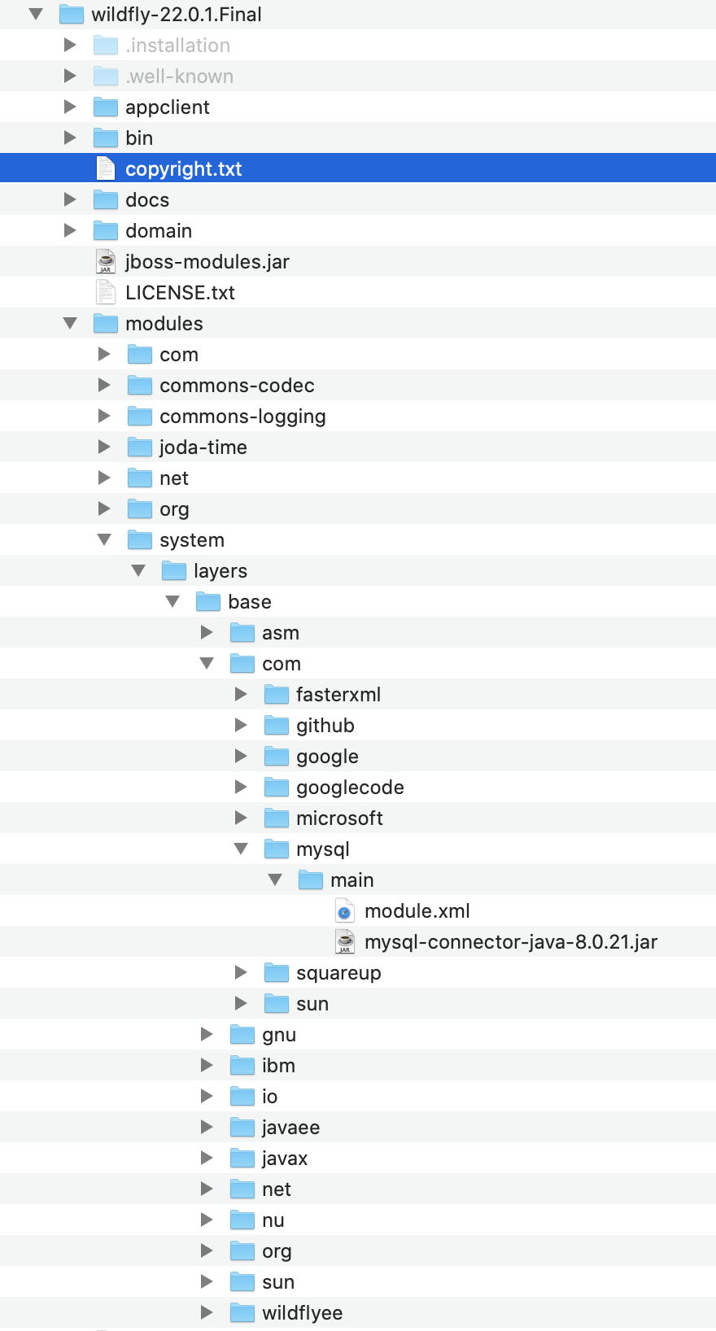

# wildfly-22.0.1.Final/modules/system/layers/base/com/mysql/main/module.xml

<module xmlns="urn:jboss:module:1.3" name="com.mysql">

<resources>

<resource-root path="mysql-connector-java-8.0.21.jar"/>

</resources>

<dependencies>

<module name="javax.api"/>

<module name="javax.transaction.api"/>

<module name="javax.servlet.api" optional="true"/>

</dependencies>

</module>

# **Create database schema**

# CREATE SCHEMA `camunda715db` ;

# **Import database:**

# camunda-bpm-wildfly-7.15.0/sql/create/mysql_engine_7.15.0.sql

# camunda-bpm-wildfly-7.15.0/sql/create/mysql_identity_7.15.0.sql

# **Restart server:**

sumit@sumits-mbp camunda-bpm-wildfly-7.15.0 % ./start-camunda.sh

Camunda wildly installation